**OUTPUT SCREENSHOT:**

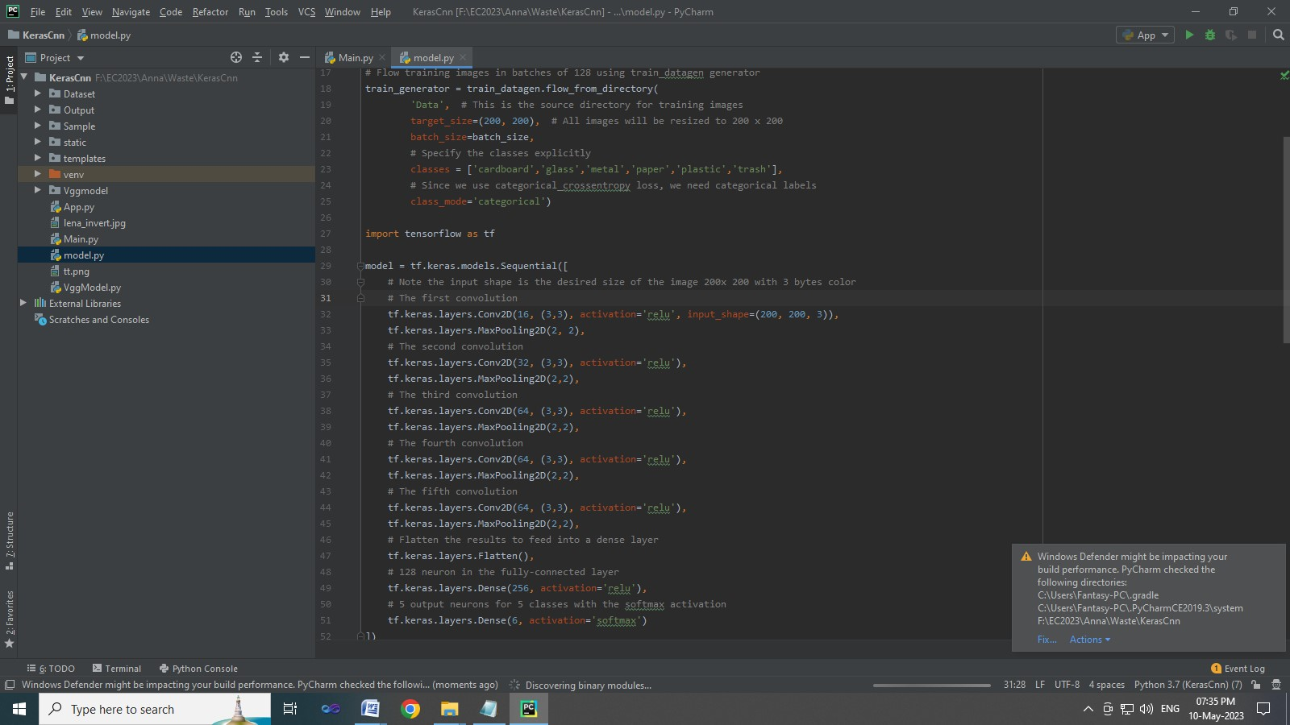

**TRAINING ACCURACY:**

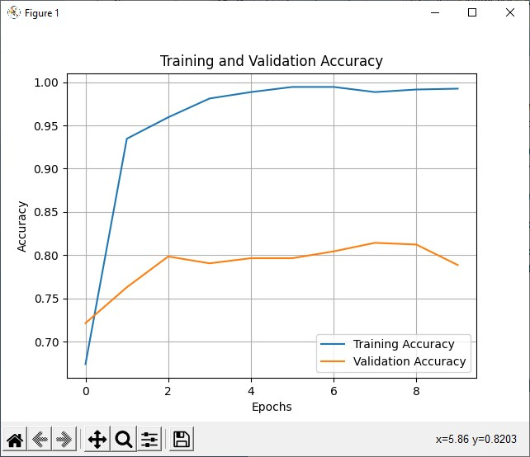

**HOME PAGE:**

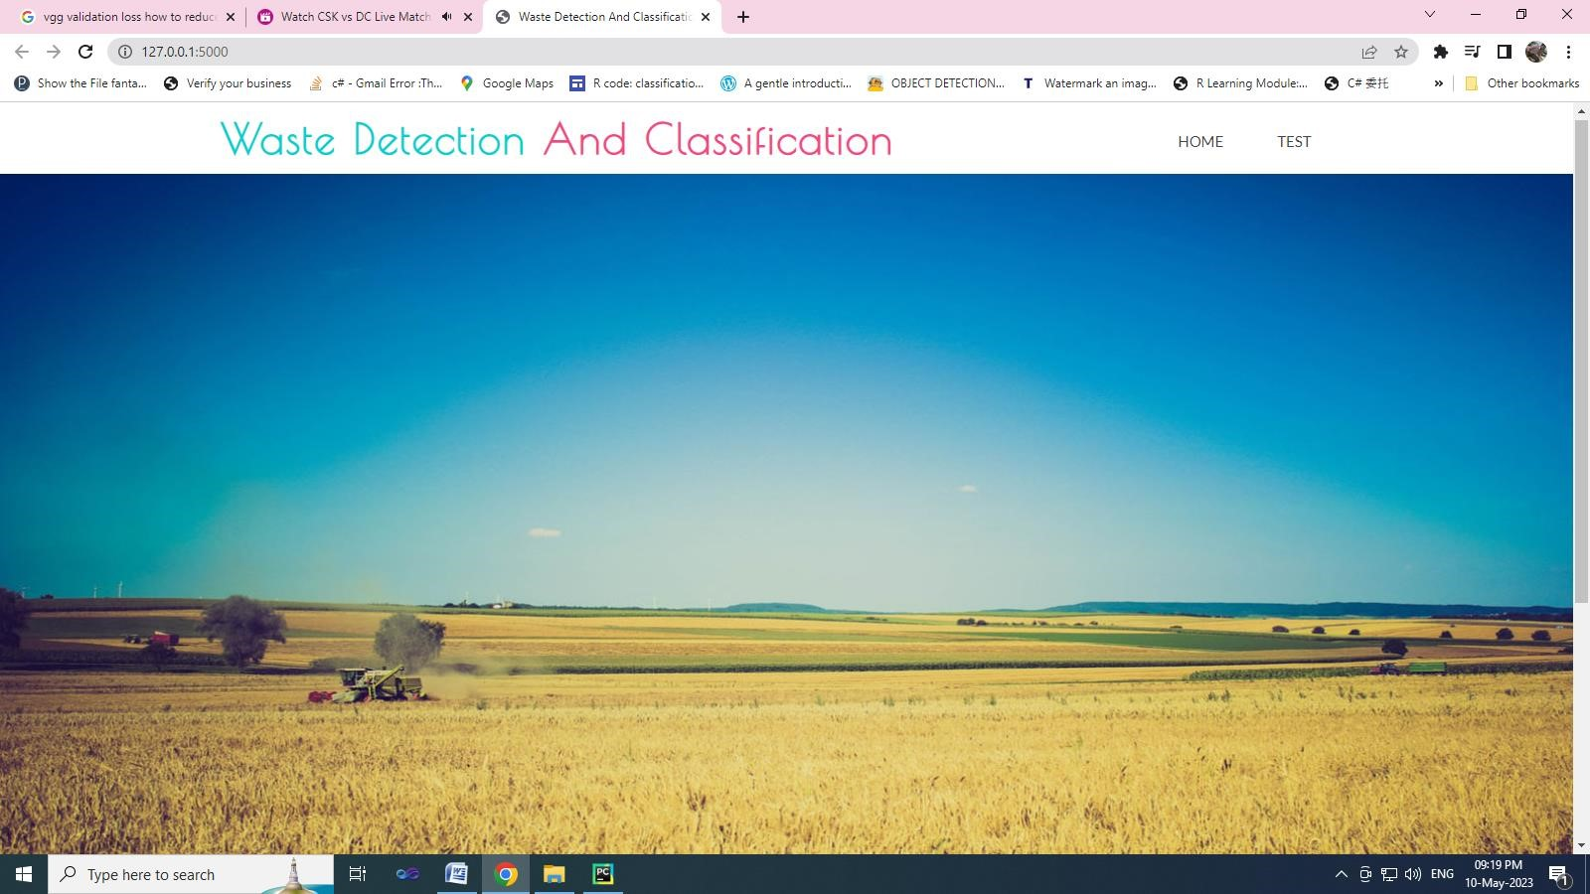

**IMAGE UPLOAD:**

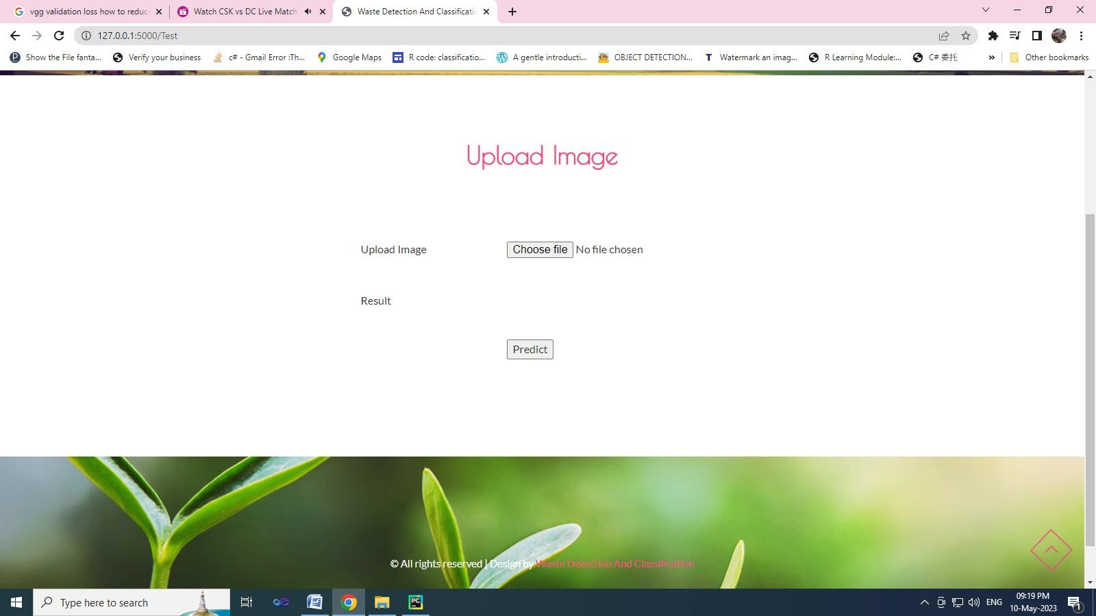

**IMAGE SELECTION:**

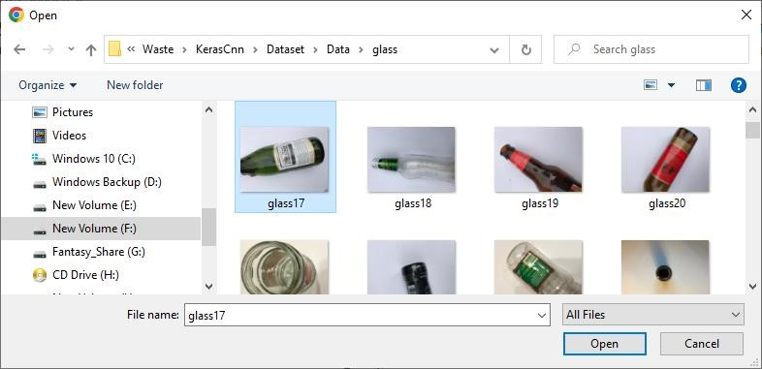

**CLASSIFICATION RESULTS:**

